Embeddings 2

Source: https://people.ischool.berkeley.edu/~dbamman/nlp20_slides/9_embeddings_2.pdf

Subword model
- Learn representations for set of n-grams instead of words
- Word representation as sum of n-gram representations:
- Advantage: needs less data
- Limitation: need to train word embeddings on large collection of unlabeled domain-specific text

Attention
- Importance vector
- Multi-head attention with many
- Hierarchical attention: sentence representation with word attention/document representation with sentence attention

RNN Architectures
- Stacked RNN
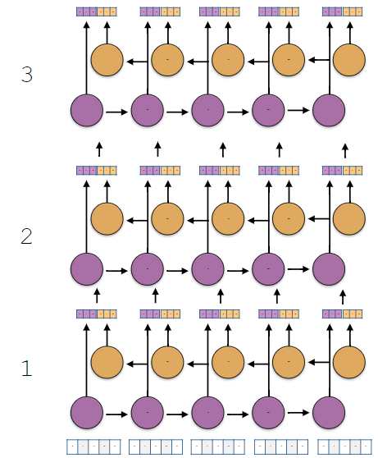
- Bidirectional RNN
  - Condition on past and future
  - Separate parameters to train, output vectors will be twice the size
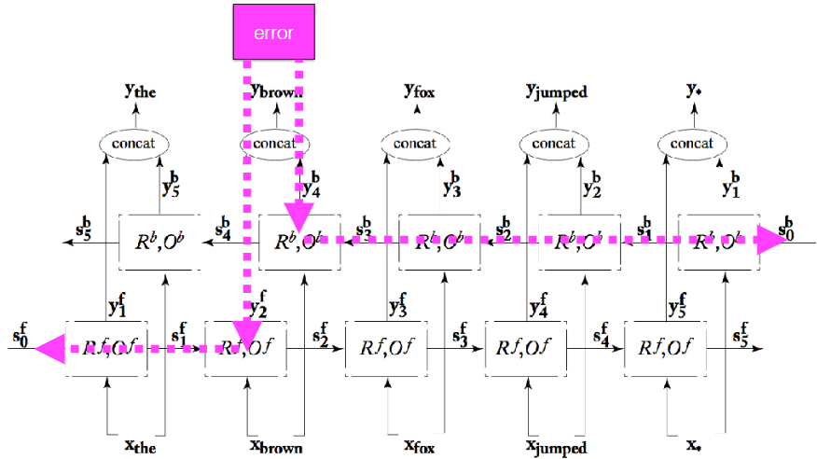

Contextualized word representation:
- Make word representation sensitive to local context
- ELMo: stacked BiRNN
- BERT:
  - Transformer model: predict masked word using bidirectional context and next sentence
  - WordPiece tokenization, sentence encoding (CLS token at beginning and SEP token at end)
  - Pre-trained on Wikipedia (2.5B words)/BookCorpus (0.8B words)
  - Parameter optimization:
    - Masked language modeling: mask one word and try to predict
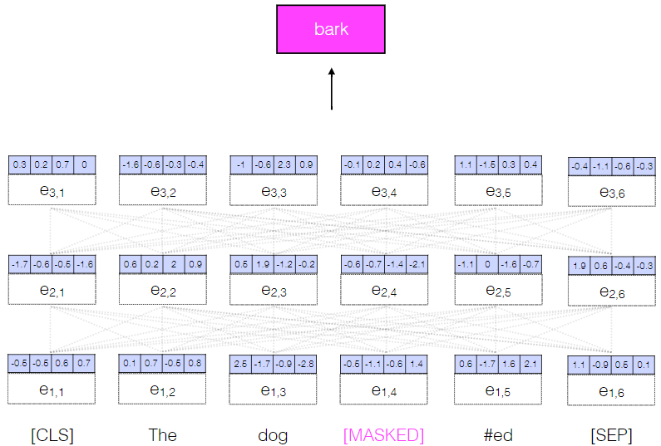
    - Next sentence prediction: for a sentence pair, predict sequential appearance using CLS token
